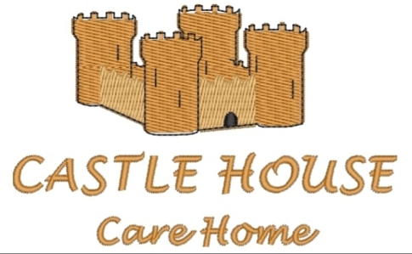
Editor: Sue Stone
Welcome to our MAY ISSUE 2026 monthly newsletter


The weather has not been kind for the first few weeks in May, very disappointing and quite chilly, especially in the evenings. However, for Bank holiday weekend they say a heat wave is on the cards – quick let’s get the BBQ’s ready and enjoy the outside!

NEWS IN BRIEF

- Once again, we celebrated our yearly May Fair on 7th May - enjoying the children dancing around the May Pole and the carnival atmosphere of the fairground

- On May 9th the May Queen and her entourage from Blue Coats Primary School arrived at the Home to show off their wonderful attire

- We have/will be celebrating so many staff and resident’s birthdays during May, our local card shop have had to increase their stock! – such a busy month!

- We have had another busy month of entertainment from Betty of the Hummingbirds, Father Steve from the church, Therapy Tails with their array of animals, PAT dog with Lucy & Jane, reflexology from Rainbow Therapy, watching the Mayfair with a hot drink and a look around the fair, day trip outings to the local commons and café, sitting outside with a glass of wine and chatting in the garden when the weather was kind, making friends with different dogs visiting, puzzles, games and exercises with our new instructors from Function Fitness.

- A reminder that your RSVP to our Summer Fair, which is being held on Saturday 15th August, is requested back by 14th June – we look forward to seeing you!

ENJOYING MAY FAIR 2026



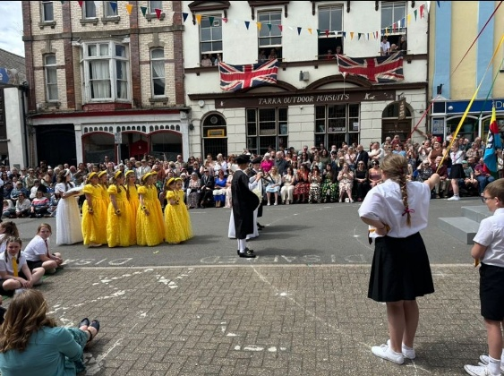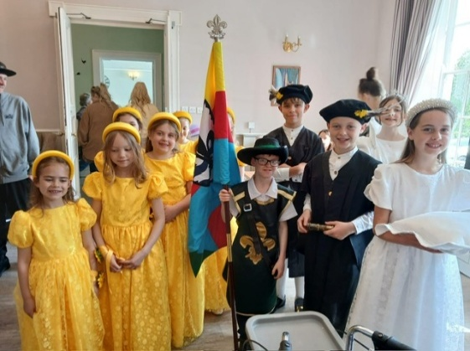

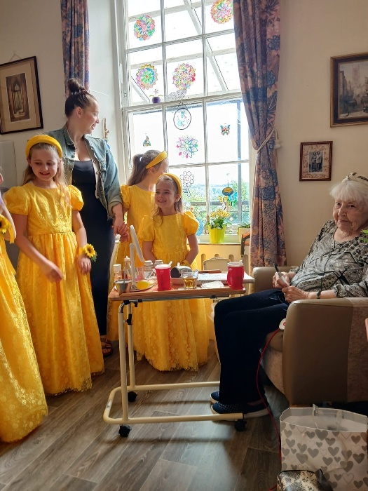

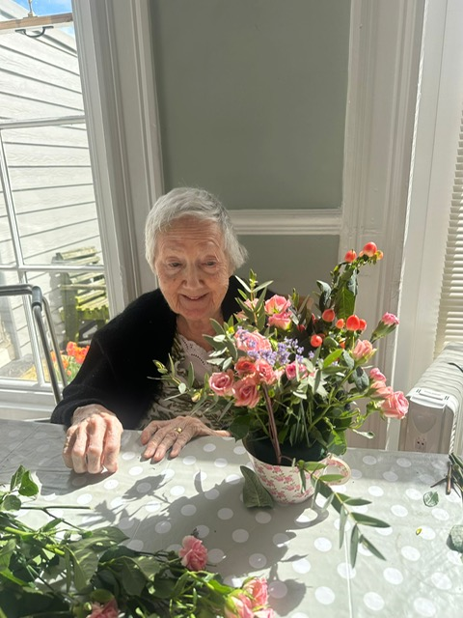

Betty from the Hummingbirds
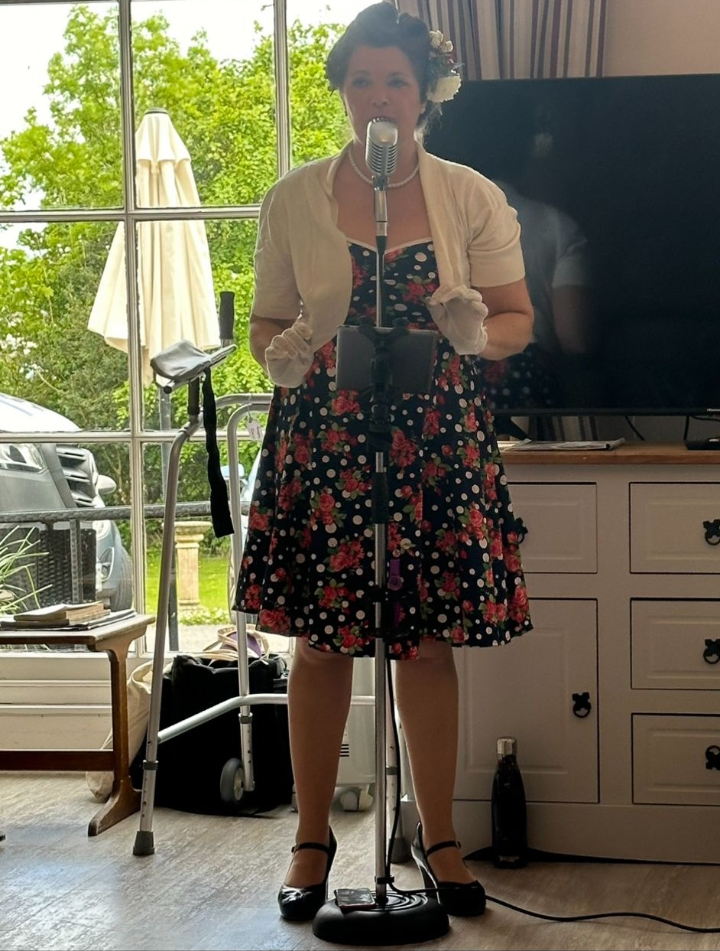

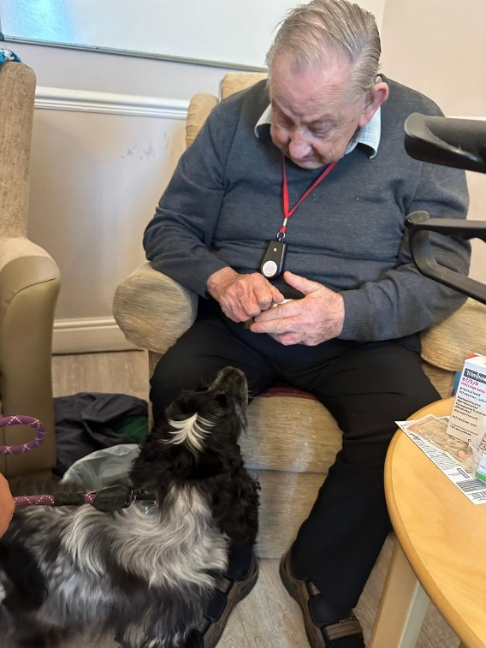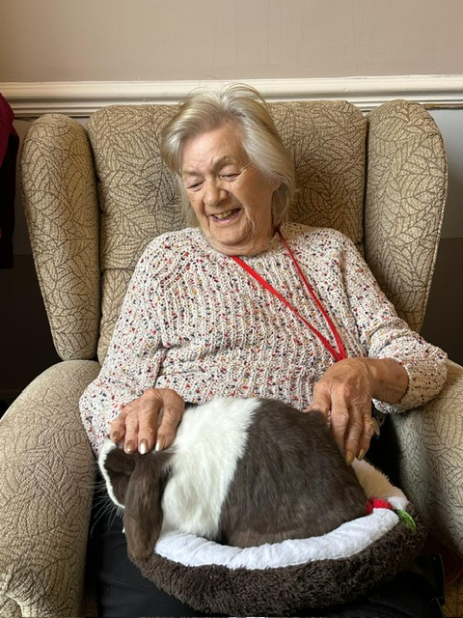

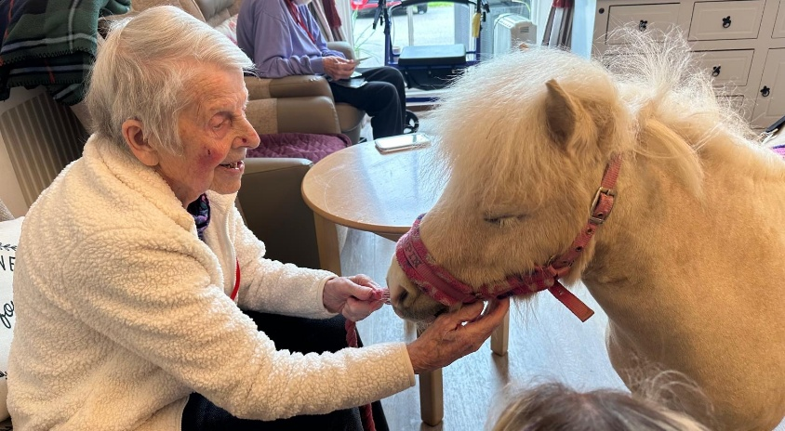

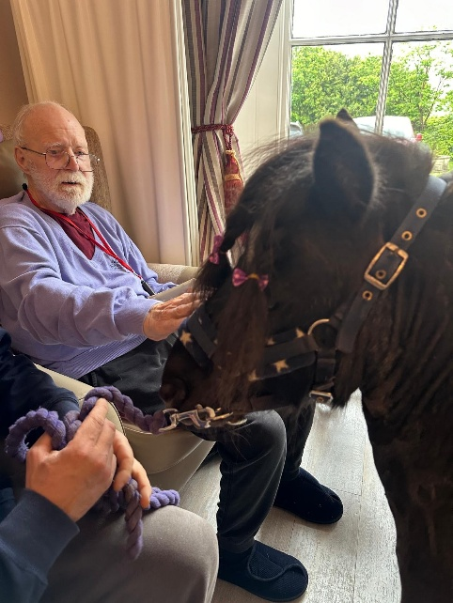

Function Fitness

Charlie & Nicole


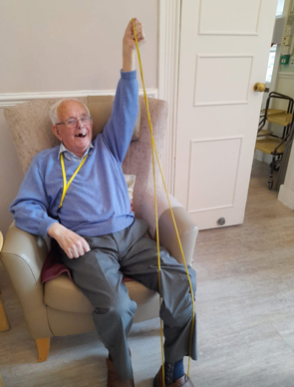

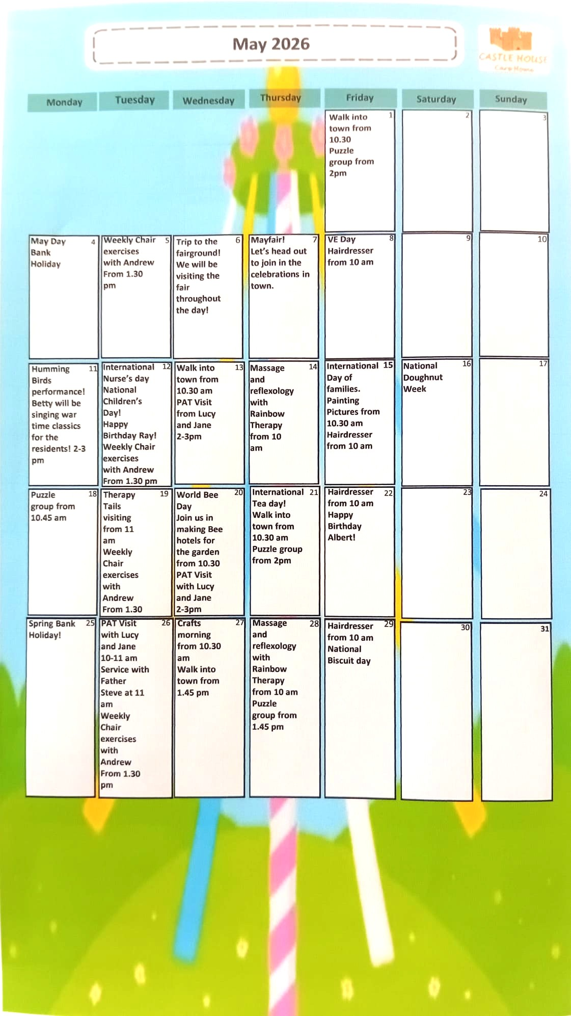



To our residents


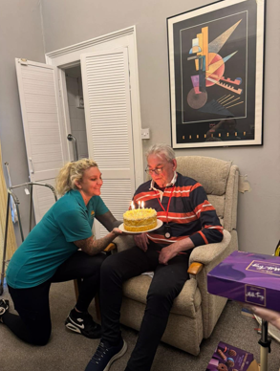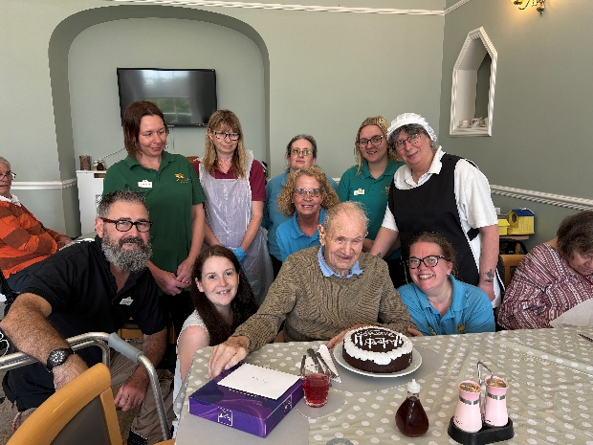
Ray Albert



To all our staff

Louise Emma 
Amanda Toni

Anumod


Answers to last months teaser puzzles:

Answer 1) Label – the hour number relates to the position in the alphabet of each letter

Answer 2) Require – it’s the only word that doesn’t contain double letters

Did you manage to get them??? – well done if you did

To test your little grey cells this month!!
Question 1) There are siz different first letters when you write out the numbers one to ten. What common word can you spell using all of these six letters
ONE TWO THREE FOUR FIVE SIX SEVEN EIGHT NINE TEN

Question 2) Changing the first letter of each of these words will creat new words with a theme in common. What is the common theme?

DOG PAIN FIST MAIL

Once again, a big


to all the staff for keeping everyone safe and well

Check out our website,
take a look at:
www.castlehousecarehomedevon.co.uk
We need your reviews….
Calling all residents friends and families. We need your reviews. If you like what we do, we would really appreciate a review. However, if you have any concerns, please do speak to us directly so we can help. You can review us on www.carehome.co.uk AND Facebook.


